# Propellor calculation description

## Flowchart

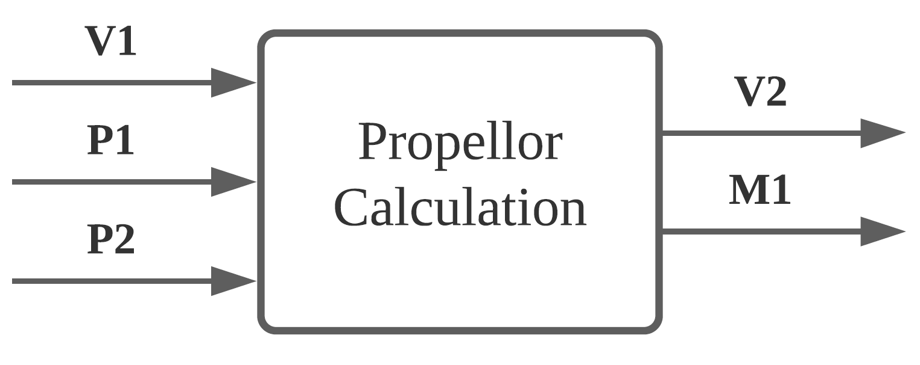

Figure 1 Propellor component flowchart

## Unique identifiers

|  |  |
| --- | --- |
| Unique ID | Long Name |
| V1 | Input from user-interface sub-system |
| P1 | Input from gearing component |
| P2 | Input from bearing component |
| V2 | Output to user-interface sub-system |
| M1 | Feedback to motor component |

## Table of limits

|  |  |  |  |  |
| --- | --- | --- | --- | --- |
| Interaction | Symbol | Min. | Max. | Unit |
| -> V1 | | | | |
| *Input from user-interface sub-system* | | | | |
| Propeller diameter | $$d_{prop}$$ | 0,1 | 0,5 | m |
| Liquid density | $$ρ$$ | 980 | 1000 | kg/m3 |
| Channel area (water stream) | A | 5*10-3 | 1 | [m2] |
| Propeller coefficient | $$K_{T}$$ | - | 0,47 | - |
| $$K_{Q}$$ | - | 0,065 | - |
| -> P1 | | | | |
| *Input from gearing component* | | | | |
| Gearing rotation speed output | $$ω_{Gear-out}$$ | 0 | 2200 | rpm |
| -> P2 | | | | |
| *Input from bearing component* | | | | |
| Bearing power output | $$P_{Bearing-out}$$ | 0 | 8400 | W |
| Bearing torque output | $$T_{Bearing-out}$$ | 0 | 3500 | Nm |
| <- V2 | | | | |
| *Output to user-interface sub-system* | | | | |
| Thrust | $$F_{T}$$ | 0 | 500 | N |
| Rotational speed propeller | $$ω_{P}$$ | 0 | 2200 | rpm |
| Power output | $$P_{output}$$ | 0 | 8400 | W |
| Power loss | $$P_{loss}$$ | 0 | 8400 | W |
| <- M1 | | | | |
| *Feedback to motor component* | | | | |
| Torque error | $$T_{error}$$ | 0 | 3500 | Nm |